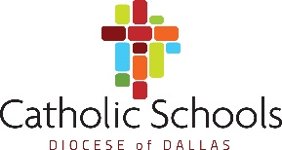

Name: Enter text here.
Date: Enter text here.

Please respond briefly to each of the following questions and submit them by e-mail to mfriend@cathdal.org

The education of the whole child is a focus in Catholic schools. How would you see yourself, as you work with the students, nurturing not only strong academic growth, but also their faith life, spiritual growth, and moral development?
Enter text here.

What has been one of the most rewarding times in your teaching experience?
Enter text here.

What has been one of the most challenging times in your teaching experience?
Enter text here.

Briefly describe how you structure an instructional class period.
Enter text here.

Identify a current or relatively current trend or innovation in Education. Describe how you think it could impact student learning/success, and discuss why or why not you would implement it if you were given the option.
Enter text here.

